

Instructor-Led Course Promotion – Chapters

- Email Copy

To: Chapter Members & Leads
From: << Chapter>>
Subject: 2019 CIA Exam Prep Courses Start <<DATE>>

Prepare to Pass the Updated CIA® Exam With
<<Chapter >>’s Instructor-Led Courses.

The Certified Internal Auditor® (CIA) exam is changing! Prepare for the updated exam with <<Chapter>>’s instructor-led CIA review courses starting <<Date>>.

Why Prepare with Us?
- Take advantage of the knowledge, experience and advice of our expert instructor, <<name, link to bio>>.
- Study the CIA exam syllabus at a manageable pace so you can absorb and understand the material, leading to success on the exam.
- Our classes provide structure and keep you on track to achieving your CIA goal.
- Network with other internal audit professionals and discuss exam topics from a variety of perspectives.

Course Details
Dates/Times: <<Insert course dates/times>>
Location: <<Insert course dates/times>>
Instructor: <<Insert course dates/times>>
Fees: <<Insert course dates/times>>
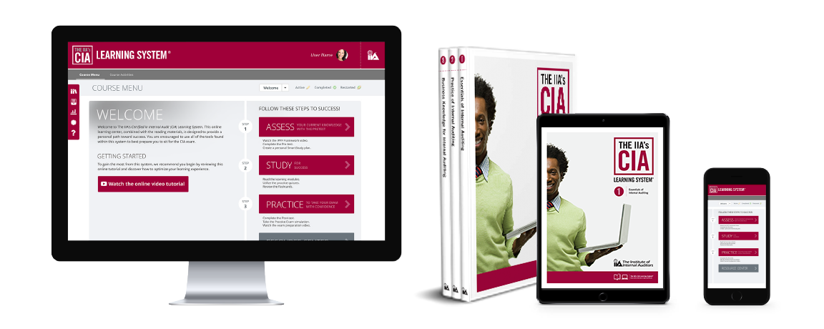
Course Materials
All course participants will receive The IIA’s CIA Learning System®, Version 6.0 study tools including comprehensive reading materials and interactive online study tools. Get complete details at www.LearnCIA.com.

Register now! (Include hyperlink to course URL) Classes fill quickly and space is limited.

For more information, please visit <<URL>>,
or contact <<name>> at <<phone>> or <<e-mail>>.

Newsletter Copy

Option 1: Live Course Announcement

Prepare to Pass the Updated CIA® Exam. <<Chapter>>’s Course Starts <<DATE>>!
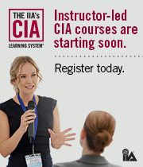
We are pleased to announce that <<Chapter>> is offering a <<number of weeks/days offered>> in-person review courses for the updated Certified Internal Auditor® (CIA) exam starting <<Date>>.

This program combines the leadership of an experienced instructor with the comprehensive reading materials and interactive online study tools of the NEW IIA’s CIA Learning System, Version 6.0 to expand your internal audit knowledge and skills and ensure you’re prepared to pass the CIA exam.

For more information or to register, please contact <<contact name>> at <<phone number>> or at <<e-mail address>> or visit <<URL>>.

Option 2: Live Course Announcement with Dates/Times

Prepare to Pass the Updated CIA® Exam. <<Chapter >>’s Course Starts <<DATE>>!

Prepare to pass the Certified Internal Auditor® (CIA) exam by enrolling in <<Chapter>>’s review course starting <<Date>>.
This program combines the leadership of our expert instructor, <<name, link to bio>>, with the comprehensive reading materials and interactive online study tools of The IIA’s CIA Learning System, Version 6.0 to expand your internal audit knowledge and skills and ensure you’re prepared to pass the CIA exam.

Discuss difficult topics with an instructor, network with your peers, and stay on track to meet your CIA goals.

The following classes are available:

Course | Date | Time | Location
Part 1: Essentials of Internal Auditing
Part 2: Practice of Internal Auditing
Part 3: Business Knowledge for Internal Auditing

For more information or to register, please contact <<contact name>> at <<phone number>> or at <<e-mail address>> or visit <<URL>>.

- Web Copy

Prepare to Pass the Updated CIA® Exam.
Enroll in our CIA Review Course Starting <<DATE>>.

The CIA exam is changing and <<Chapter>> is ready to help you prepare!

Join our CIA review course led by our expert instructor, <<Name, link to bio>>, and take advantage of all the resources included in your course registration.

COURSE BENEFITS | COURSE DETAILS
- Take advantage of the knowledge, experience and advice of our expert instructor, <<name, link to bio>>.  - Study the CIA exam syllabus at a manageable pace so you can absorb and understand the material, leading to success on the exam.  - Learn the CIA exam syllabus and apply the concepts with The IIA’s CIA Learning System, Version 6.0, included with registration.  - Stay on track to achieving your CIA goal with structured classes and study activities.  - Network with other internal audit professionals and discuss exam topics from a variety of perspectives. | Dates/Times: <<Insert course dates/times>>  Location: <<Insert course dates/times>>  Instructor: <<Insert course dates/times>>  Fees*: <<Insert course dates/times>>  REGISTER TODAY!  Questions? Contact us directly at:  <<Name>>  <<Email>>  <<Phone>>  *Fees include The IIA’s CIA Learning System materials. Contact us if you already own the materials.

COURSE MATERIALS

This course is based on The IIA’s CIA Learning System materials, the only CIA review program created and endorsed by The IIA. As part of your course registration, you’ll receive access to the following study tools:

Reading Materials  - Materials teach the entire global 3-part CIA exam syllabus:  - Part 1: Essentials of Internal Auditing  - Part 2: Practice of Internal Auditing  - Part 3: Business Knowledge for Internal Auditing  - Download books to your e-reader, read online, or use printed books.  - Topics presented in a concise, easy-to-understand format.  - Newly updated program teaches the latest CIA exam syllabi.  - Aligned with the current standards. | Online Study Tools  - Pre-test evaluates current knowledge and identifies topics requiring intensive study.  - SmartStudy™ tools help you create a customized study plan.  - Video tutorial provides an overview of the IPPF components.  - Quizzes, incorporating 500 new questions, test your comprehension and ability to apply concepts.  - Flashcards offer review of key terms and definitions.  - Post-test gauges knowledge gained and identifies areas requiring further study.  - CIA Practice Exam helps build confidence using the computer-based CIA exam software.  - Progress report tracks activities and scores.  - Online study tools are optimized for mobile devices.

Register today! Contact <<Name>> at <<e-mail address>> or <<phone>>.

