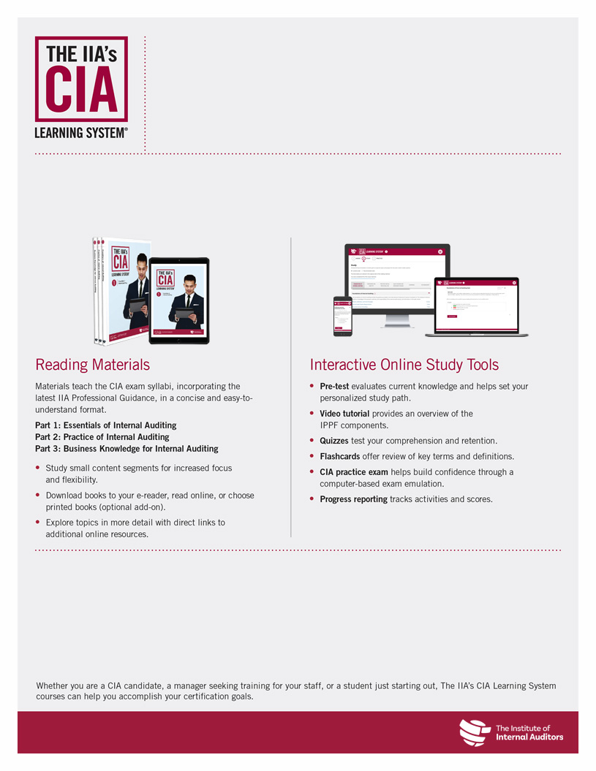

**Prepare to Pass the CIA Exam With** **<<Affiliate/Chapter/Partner>>**

For more information or to register, please visit

<<URL>>.

Upcoming Course Dates

The following courses are available through <<Affiliate/Chapter/Partner>>:

|  |  |
| --- | --- |
| **Course** | **Dates** |
| **Part 1: Essentials of Internal Auditing** | <<Dates>> |
| **Part 2: Practice of Internal Auditing** | <<Dates>> |
| **Part 3: Business Knowledge for Internal Auditing** | <<Dates>> |

CIA Review Classes Coming <<Date>>!

**<<Affiliate/Chapter/Partner>>** will be partnering with The IIA to offer CIA® review classes starting <<Date>> using The IIA’s CIA Learning System®. Our expert instructor will lead you through the global CIA exam syllabus in a structured and interactive <<live class/online class>> environment to ensure you understand and can apply the critical CIA topics.