Instructor-led Course Promotion – Chapters

Get Unparalleled CIA Exam Prep with <<Chapter Name>>.
Enroll in our Online Instructor-led Courses.

<<Chapter>> will be partnering with The IIA to offer online CIA® review classes starting <<Date>> using The IIA’s CIA Learning System®. An expert instructor will lead you through the global CIA exam syllabus in a structured and interactive online class environment to ensure you understand and can apply the critical CIA topics.

- Take advantage of the knowledge, experience and advice of our expert instructor, <<name, link to bio>>.
- Study the CIA exam syllabi and IPPF with The IIA’s CIA Learning System, Version 7.0.
- Stay motivated and on track to achieving your CIA goal.
- Chapter members save on registration fees.

Course Details
Dates/Times:
- Part 1: <<Insert course dates/times>>
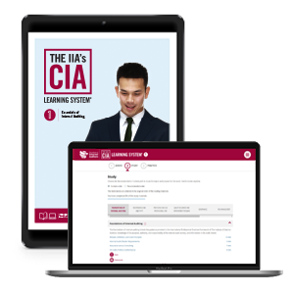
- Part 2: <<Insert course dates/times>>
- Part 3: <<Insert course dates/times>>
Instructor: <<Insert instructor name, link to bio>>
Fees: <<Insert course fee>>
Registration: <<Registration URL>>

Course Materials
You will receive access to The IIA’s CIA Learning System®, Version 7.0 for all parts in which you enroll. Enjoy online reading materials with direct links to IIA resources, quizzes, flashcards, practice exam, and more. Get complete details at www.LearnCIA.com.

Register now! (hyperlink to course URL) Classes fill quickly and space is limited.

For more information, please visit <<URL>>,
or contact <<name>> at <<phone>> or <<e-mail>>.

