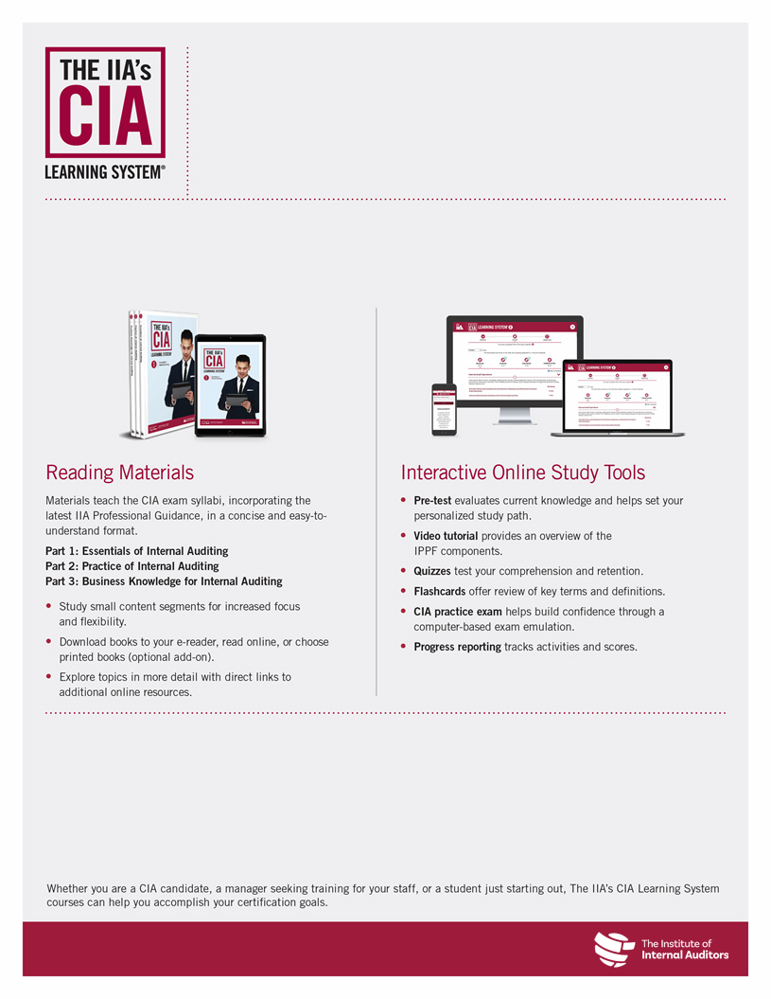
Prepare to Pass the CIA Exam With <<Affiliate/Chapter/Partner>>
For more information or to register, please visit
<<URL>>.
Upcoming Course Dates

The following courses are available through <<Affiliate/Chapter/Partner>>:
Course | Dates
Part 1: Essentials of Internal Auditing | <<Dates>>
Part 2: Practice of Internal Auditing | <<Dates>>
Part 3: Business Knowledge for Internal Auditing | <<Dates>>

CIA Review Classes Coming <<Date>>!
<<Affiliate/Chapter/Partner>> will be partnering with The IIA to offer CIA® review classes starting <<Date>> using The IIA’s CIA Learning System®. Our expert instructor will lead you through the global CIA exam syllabus in a structured and interactive <<live class/online class>> environment to ensure you understand and can apply the critical CIA topics.

