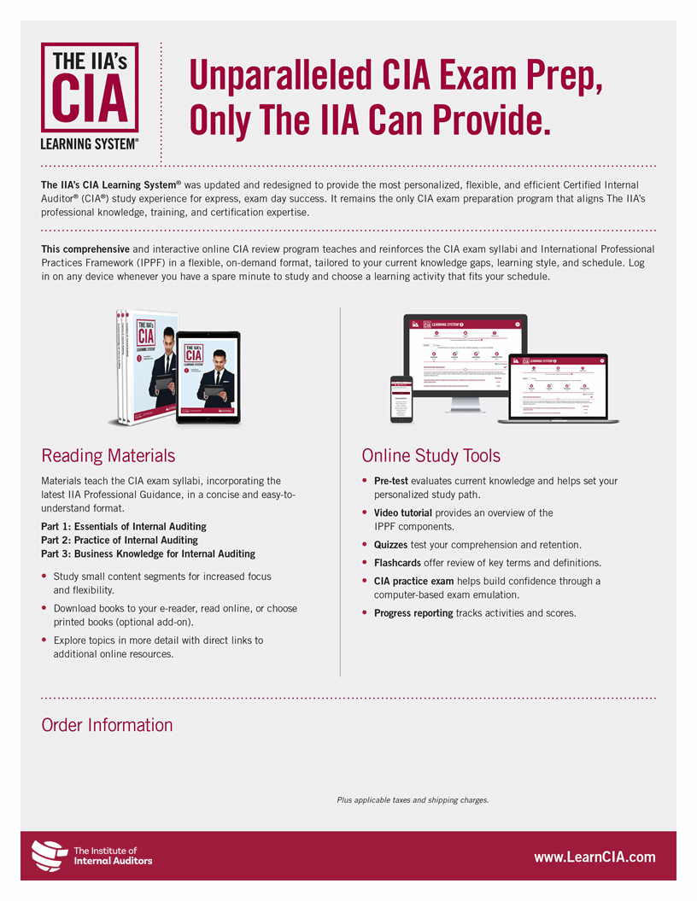
 | Individual Parts | Full Kit (Parts 1, 2, 3)
Online Only Program | <<Price>> | <<Price>>
Online + Printed Books | <<Price>> | <<Price>>

For more information, contact <<Chapter/Affiliate>> at:

<<Contact>>
<<Contact>>

<<Disclaimer>>

