

Instructor-Led Course Promotion Copy – Education Partners & Affiliates

Get Unparalleled CIA Exam Prep with <<Institution/Affiliate>>.
Enroll in our Online Instructor-led Courses <<Date Range>>.

<<Institution/Affiliate>> will be partnering with The IIA to offer online CIA® review classes starting <<Date>> using The IIA’s CIA Learning System®. An expert instructor will lead you through the global CIA exam syllabus in a structured and interactive <<in-person/online>> class environment to ensure you understand and can apply the critical CIA topics.

- Take advantage of the knowledge, experience and advice of our expert instructor, <<name, link to bio>>.
- Study the CIA exam syllabi and IPPF with The IIA’s CIA Learning System, Version 7.0.
- Stay motivated and on track to achieving your CIA goal.

Course Details
Dates/Times:
- Part 1: <<Insert course dates/times>>
- Part 2: <<Insert course dates/times>>
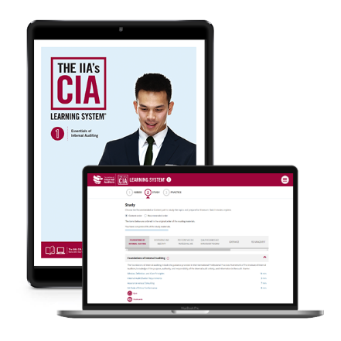
- Part 3: <<Insert course dates/times>>
Instructor: <<Insert instructor name, link to bio>>
Fees: <<Insert course fee>>
Registration: <<Registration URL>>

Course Materials
You will receive access to The IIA’s CIA Learning System®, Version 7.0 for all parts in which you enroll. Enjoy online reading materials with direct links to members-only resources, quizzes flashcards, practice exam, and more. Get complete details at www.LearnCIA.com.

Register now! (hyperlink to course URL) Classes fill quickly and space is limited.

For more information, please visit <<URL>>,
or contact <<name>> at <<phone>> or <<e-mail>>.

