

Self-study Materials Promotional Copy – Global Affiliates & Chapters

WEBSITE COPY

Prepare to Pass the CIA Exam with
The IIA’s CIA Learning System.
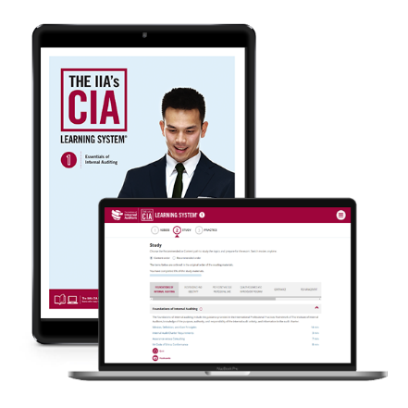
The IIA’s CIA Learning System Version 7.0 is designed to help you pass the exam parts with speed. It is a comprehensive and interactive CIA review program that teaches and reinforces the updated CIA exam syllabi and International Professional Practices Framework (IPPF) in a flexible, on-demand format, tailored to current knowledge gaps, learning style, and schedule. Online quizzes, study tools and reading materials (printed books available as an optional add-on), provide candidates with the most personalized, flexible, and efficient study experience for express, exam day success.

No other study tool aligns The IIA’s professional knowledge, training, and certification expertise.
- More Practice Questions: We added nearly 400 NEW questions in 2022! Now, with more than 2600 practice questions, you can test your knowledge and build your confidence.
- Personalized Study Experience: Leverage an individualized study plan that prioritizes content based on your personal knowledge gaps and follows your progress through quiz scores and activities.
- Microlearning: Focus on smaller content segments, with estimated study times, to make the most efficient use of your available time and ensure you have a clear understanding of each topic.
- Convenience: Travel light with online access via any mobile device, tablet, or computer. Just log in and continue where you left off. Take advantage of downtime with study tools that are accessible 24/7.
- IIA Member Benefit: IIA members can click-through to members-only recommended guidance directly from the Learning System’s online study tools!

CIA Exam Preparation Resources from the Experts

Log in on any device whenever you have a spare minute to study! Online study tools offer a recommended study path, learning activity options with time estimates, and progress tracking.

Online Reading Materials
Reading materials teach the CIA exam syllabi, incorporating the latest IIA Professional Guidance, in a concise and easy-to-understand format.
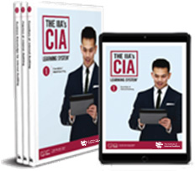
- Learn the entire CIA exam syllabus and The IIA’s most current professional knowledge.
  - Part 1: Essentials of Internal Auditing
  - Part 2: Practice of Internal Auditing
  - Part 3: Business Knowledge for Internal Auditing
- Download books to your e-reader, read online, or choose printed books (optional add-on).
- Explore topics in more detail online with direct links to additional resources.

Interactive Online Study Tools
Enjoy a dynamic online study experience that prioritizes topics based on your personal knowledge gaps and tracks your progress through more than 2600 practice questions and study activities.

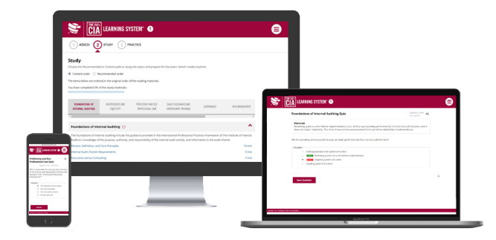
- Pre-test: Evaluates current knowledge and helps set your personalized study path.
- Quizzes: Apply and test your knowledge and retention.
- Video Tutorial: Provides an overview of the IPPF components
- Flashcards: Review key terms and definitions.
- CIA Practice Exam: Build confidence through a computer-based exam emulation.
- StudyPLUS: Get CIA exam tips and tools in this CIA exam prep guide.
- Online Access Period: Purchasers of an individual part will have access to the online study tools for one year from date of purchase. Purchasers of a full, three-part kit will have access for two years from date of purchase.

Pricing
- Full, 3-part kit: <<Insert Price>> (Add <<insert price>> plus shipping & taxes for printed books)
- Individual parts: <<Insert Price>> (Add <<insert price>> plus shipping & taxes for printed books)

Order Today! (hyperlink to ecommerce/purchase page)

For more information, contact <<name>> at <<phone>> or <<e-mail>>.

NEWSLETTER/EMAIL COPY

Subject: Ready to Become a Certified Internal Auditor?

As the only globally recognized certification for internal auditors, the Certified Internal Auditor® (CIA®) designation demonstrates that you are a credible and proficient internal audit leader.
One of the first steps to becoming a CIA is to prepare for the CIA exam. More than 75,000 professionals have trusted The IIA’s CIA Learning System to help them prepare to pass. No other study tool aligns The IIA’s professional knowledge, training, and certification expertise.
- Learn the complete CIA exam syllabi and Professional Guidance.
- Practice with more than 2600 online questions.
- Study online anytime with mobile-optimized study tools including reading materials, quizzes, flashcards, and practice exams.

Build your knowledge and confidence for the CIA exam with help from The IIA!

Purchase Now! (Insert hyperlink to ecommerce/purchase page)

